ANGULAR HANDS ON 10
Figure 1: Angular Application Output
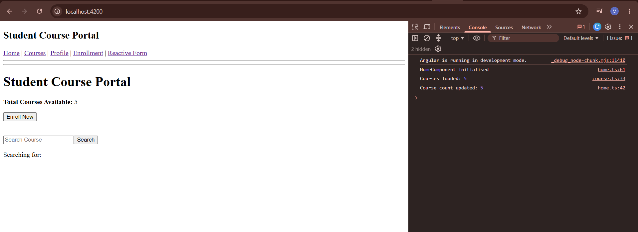

Figure 2: Application Execution
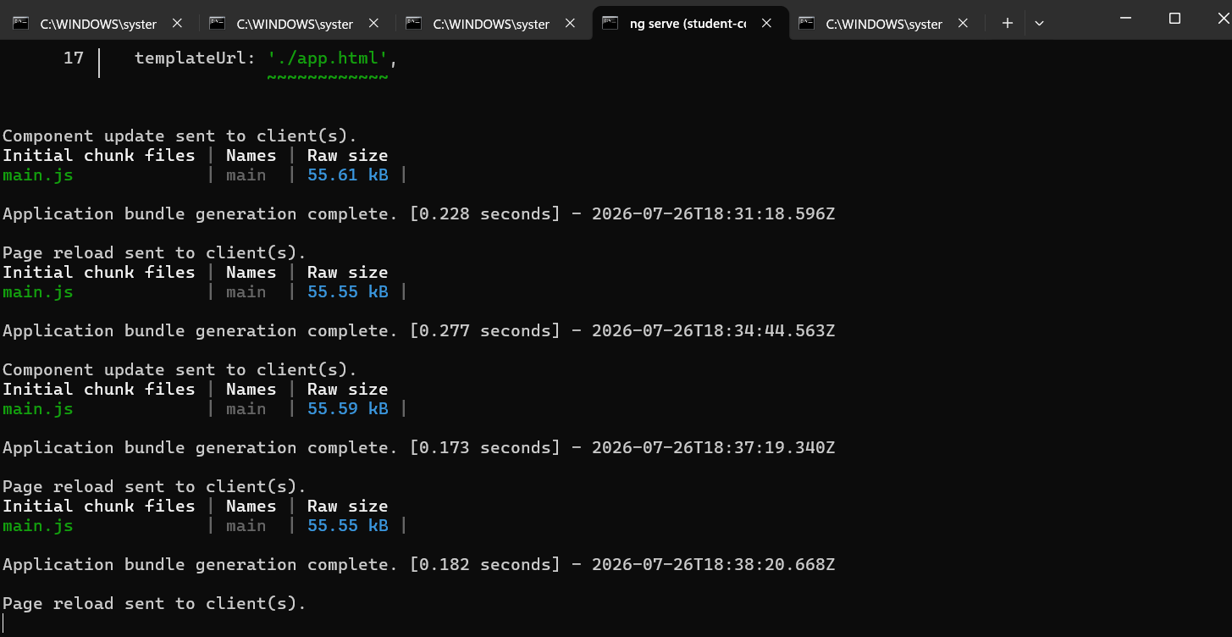

Objective
To understand and implement unit testing in Angular applications using Jasmine, Karma and TestBed. This hands-on focuses on testing Angular components, services and application logic.

Description
Angular unit testing helps verify that individual components and services work correctly. Jasmine is used for writing test cases, Karma executes the tests, and TestBed provides an Angular testing environment for creating and testing components.

Concepts Covered
• Jasmine testing framework – describe(), it(), expect() and spyOn().
• Karma test runner for executing Angular test cases.
• TestBed for configuring and creating Angular testing environments.
• Component testing using fixtures and DebugElement.
• Testing services using HttpClientTestingModule.
• Mock testing using MockStore for state management.

Implementation Summary
The Angular application was tested by creating unit test cases for components and services.

Component testing verifies:
• Component creation
• Input value rendering
• Output event handling
• Change detection behaviour

Service testing verifies:
• HTTP requests
• API response handling
• Error handling

Mock testing is used to simulate application states during testing.
Result
The Angular application was successfully executed and the concepts of unit testing using Jasmine, Karma and Test.

